**CHAPTER 1**

**INTRODUCTION**

1. **Android** 
   * **Android** is a mobile operating system developed by Google, based on a modified version of the Linux kernel and other open source software and designed primarily for touchscreen mobile devices such as smartphones and tablets.
   * Initially developed by Android Inc., which Google bought in 2005, Android was unveiled in 2007, with the first commercial Android device launched in September 2008.
   * The operating system has since gone through multiple major releases, with the current version being 8.1 "Oreo", released in December 2017.
   * Android's default user interface is mainly based on direct manipulation, using touch inputs that loosely correspond to real-world actions, like swiping, tapping, pinching, and reverse pinching to manipulate on-screen objects, along with a virtual keyboard.
   * Android devices boot to the homescreen, the primary navigation and information "hub" on Android devices, analogous to the desktop found on personal computers.
   * Applications, which extend the functionality of devices, are written using the Android software development kit (SDK)and, often, the Java programming language. Java may be combined with [C](https://en.wikipedia.org/wiki/C_(programming_language))/C++,together with a choice of non-default runtimes that allow better C++ support..

1. **Android Application**

* Android software development is the process by which new applications are created for devices running the Android operating system.
* Apps can be written using [Java](https://en.wikipedia.org/wiki/Java_(programming_language)), [C++](https://en.wikipedia.org/wiki/C%2B%2B) or [Kotlin](https://en.wikipedia.org/wiki/Kotlin_(programming_language)) using the Android [software development kit](https://en.wikipedia.org/wiki/Software_development_kit) (SDK). Third party tools, development environments and language support have also continued to evolve and expand since the initial SDK was released in 2008.
* The Android software development kit (SDK) includes a comprehensive set of development tools. These include a debugger, libraries, a handset emulator based on QEMU, documentation, sample code, and tutorials.
* Enhancements to Android's SDK go hand in hand with the overall Android platform development. The SDK also supports older versions of the Android platform in case developers wish to target their applications at older devices. Development tools are downloadable components, so after one has downloaded the latest version and platform, older platforms and tools can also be downloaded for compatibility testing.
* Android applications are packaged in .apk format and stored under /data/app folder on the Android OS (the folder is accessible only to the root user for security reasons). APK package contains .dex files (compiled byte code files called Dalvik executables), resource files, etc.
* The Android Debug Bridge (ADB) is a toolkit included in the Android SDK package. It consists of both client and server-side programs that communicate with one another. The ADB is typically accessed through the command-line interface,although numerous graphical user interfaces exist to control ADB
* Libraries written in C/C++ can be compiled to ARM, or x86 native code (or their 64-bit variants); or MIPS while both the 32-bit and 64-bit variants of are deprecated; and installed using the Android Native Development Kit (NDK). These native libraries can be called from Java code running under the Android Runtime using the System.loadLibrary call, which is part of the standard Android Java classes

**CHAPTER 2**

**REQUIREMENTS SPECIFICATION**

**2.1 Purpose of the requirements document**

The software requirement specification is the official statement of what is required for development of particular project. It includes both user requirements and system requirements. This requirement document is utilized by variety of users starting from project manager who gives project to the engineer responsible for development of project.

It should give details of how to maintain, test, verify and what all the actions to be carried out through life cycle of project.

**2.1.1 Scope of the project**

The scope is to create a mobile application which runs efficiently with minimum use of battery and memory. We make use of different concepts such as layout , create activity, notifications.

**2.2 Specific requirements**

**2.2.1 User Requirement**:

* Easy to understand and should be simple.
* The built-in functions should be utilized to maximum extent.

**2.2.2 Software Requirements:**

* Platform used: WINDOWS
* Android Software Development kit
* Android Studio
* Language: JAVA

**2.2.3 Hardware Requirements:**

* Processor-Intel or AMD(Advanced Micro Devices)
* RAM-512MB(minimum)
* Hard Disk-1MB(minimum)
* Mouse
* Keyboard
* Monitor

**CHAPTER 3**

**IMPLEMENTATION**

**3.1. Source Code**

**3.1.1. ANDROID MANIFEST FILE**

<?xml version="1.0" encoding="utf-8"?>  
<manifest xmlns:android="http://schemas.android.com/apk/res/android"  
package="com.example.timetableproject">  
  
<application  
android:allowBackup="true"  
android:icon="@mipmap/ic_launcher"  
android:label="@string/app_name"  
android:roundIcon="@mipmap/ic_launcher_round"  
android:supportsRtl="true"  
android:theme="@style/AppTheme">  
<activity  
android:name=".MainActivity"  
android:label="@string/app_name"  
android:theme="@style/AppTheme.NoActionBar">  
<intent-filter>  
<action android:name="android.intent.action.MAIN" />  
  
<category android:name="android.intent.category.LAUNCHER" />  
</intent-filter>  
</activity>  
<activity android:name=".AddSubject"></activity>  
<activity android:name=".AddFaculty"></activity>  
<activity android:name=".Monday"></activity>  
<activity android:name=".AddSubjectTime"></activity>  
<activity android:name=".Tuesday"></activity>  
<activity android:name=".Wednesday"></activity>  
<activity android:name=".Thursday"></activity>  
<activity android:name=".Friday"></activity>  
<activity android:name=".Saturday"></activity>  
<activity android:name=".Displaysyllabus"></activity>  
<activity android:name=".DisplayFaculty"></activity>  
</application>

**3.1.2. JAVA CODES**

**3.1.2.1 Main Activity**

package com.example.timetableproject;  
  
import android.support.v4.app.FragmentManager;  
import android.os.Bundle;  
import android.support.design.widget.NavigationView;  
import android.support.v4.view.GravityCompat;  
import android.support.v4.widget.DrawerLayout;  
import android.support.v7.app.ActionBarDrawerToggle;  
import android.support.v7.app.AppCompatActivity;  
import android.support.v7.widget.Toolbar;  
import android.view.Menu;  
import android.view.MenuItem;  
  
public class MainActivity extends AppCompatActivity  
 implements NavigationView.OnNavigationItemSelectedListener {  
  
 NavigationView navigationView=null;  
 Toolbar toolbar=null;  
  
 FragmentManager;  
 @Override  
 protected void onCreate(Bundle savedInstanceState) {  
 super.onCreate(savedInstanceState);  
 setContentView(R.layout.*activity_main*);  
  
 fragmentManager=getSupportFragmentManager();  
 fragmentManager.beginTransaction().replace(R.id.*frame*,new Home()).commit();  
  
 toolbar = (Toolbar) findViewById(R.id.*toolbar*);  
 setSupportActionBar(toolbar);  
  
 DrawerLayout drawer = (DrawerLayout) findViewById(R.id.*drawer_layout*);  
 ActionBarDrawerToggle toggle = new ActionBarDrawerToggle(  
 this, drawer, toolbar, R.string.*navigation_drawer_open*, R.string.*navigation_drawer_close*);  
 drawer.addDrawerListener(toggle);  
 toggle.syncState();  
  
 navigationView = (NavigationView) findViewById(R.id.*nav_view*);  
 navigationView.setNavigationItemSelectedListener(this);  
 }  
  
  
 @Override  
 public void onBackPressed() {  
 DrawerLayout drawer = (DrawerLayout) findViewById(R.id.*drawer_layout*);  
 if (drawer.isDrawerOpen(GravityCompat.*START*)) {  
 drawer.closeDrawer(GravityCompat.*START*);  
 } else {  
 super.onBackPressed();  
 }  
 }  
  
 @Override  
 public boolean onCreateOptionsMenu(Menu menu) {  
 getMenuInflater().inflate(R.menu.*main*, menu);  
 return true;  
 }  
  
 @Override  
 public boolean onOptionsItemSelected(MenuItem item) {  
 int id = item.getItemId();  
 if (id == R.id.*action_settings*) {  
 return true;  
 }  
 return super.onOptionsItemSelected(item);  
 }  
  
 @SuppressWarnings("StatementWithEmptyBody")  
 @Override  
 public boolean onNavigationItemSelected(MenuItem item) {  
 fragmentManager=getSupportFragmentManager();  
 int id = item.getItemId();  
  
 if (id == R.id.*nav_home*){  
 fragmentManager.beginTransaction().replace(R.id.*frame*,new Home()).commit();  
 }else if (id == R.id.*nav_syllabus*) {  
 fragmentManager.beginTransaction().replace(R.id.*frame*,new Syllabus() ).commit();  
 } else if (id == R.id.*nav_faculty*) {  
 fragmentManager.beginTransaction().replace(R.id.*frame*,new Faculty() ).commit();  
 } else if (id == R.id.*nav_coe*) {  
 fragmentManager.beginTransaction().replace(R.id.*frame*,new COE() ).commit();  
 }  
 else if(id == R.id.*nav_exit*) {  
 finish();  
 }  
  
 DrawerLayout drawer = (DrawerLayout) findViewById(R.id.*drawer_layout*);  
 drawer.closeDrawer(GravityCompat.*START*);  
 return true;  
 }  
}

**3.1.2.2 Home**

package com.example.timetableproject;  
  
import android.content.Intent;  
import android.support.v4.app.Fragment;  
import android.os.Bundle;  
import android.support.annotation.Nullable;  
import android.view.LayoutInflater;  
import android.view.View;  
import android.view.ViewGroup;  
import android.widget.AdapterView;  
import android.widget.ArrayAdapter;  
import android.widget.ListView;  
  
import java.util.ArrayList;  
import java.util.List;  
  
import butterknife.ButterKnife;  
  
public class Home extends Fragment {  
 View myView;  
  
 ArrayAdapter<String> listViewAdapter;  
 ArrayList<String> Days= new ArrayList<String>();  
  
 @Nullable  
 @Override  
 public View onCreateView(LayoutInflater inflater, @Nullable ViewGroup container, Bundle savedInstanceState) {  
 myView=inflater.inflate(R.layout.*home*,container,false);  
 Days.add("Monday");  
 Days.add("Tuesday");  
 Days.add("Wednesday");  
 Days.add("Thursday");  
 Days.add("Friday");  
 Days.add("Saturday");  
 Days.add("Sunday");  
 ListView lv=myView.findViewById(R.id.*day_list*);  
 registerForContextMenu(lv);  
 listViewAdapter=new ArrayAdapter<String>(getActivity(), android.R.layout.*simple_list_item_1*, Days);  
 lv.setAdapter(listViewAdapter);  
 lv.setOnItemClickListener(new AdapterView.OnItemClickListener() {  
 @Override  
 public void onItemClick(AdapterView<?> adapterView, View, int i, long l) {  
 switch(i){  
 case 0: Intent monday=new Intent(myView.getContext(),Monday.class);  
 startActivity(monday);  
 break;  
 case 1: Intent tuesday=new Intent(myView.getContext(),Tuesday.class);  
 startActivity(tuesday);  
 break;  
 case 2: Intent Wednesday=new Intent(myView.getContext(),Wednesday.class);  
 startActivity(Wednesday);  
 break;  
 case 3: Intent Thursday=new Intent(myView.getContext(),Thursday.class);  
 startActivity(Thursday);  
 break;  
 case 4: Intent Friday=new Intent(myView.getContext(),Friday.class);  
 startActivity(Friday);  
 break;  
 case 5: Intent Saturday=new Intent(myView.getContext(),Saturday.class);  
 startActivity(Saturday);  
 break;  
 }  
 }  
 });  
 super.onCreate(savedInstanceState);  
 return myView;  
 }  
  
}

**3.1.2.3 Day**

package com.example.timetableproject;  
  
import android.content.Intent;  
import android.os.Bundle;  
import android.support.annotation.Nullable;  
import android.support.design.widget.FloatingActionButton;  
import android.support.v7.app.AppCompatActivity;  
import android.view.View;  
import android.widget.ArrayAdapter;  
import android.widget.ListView;  
  
import java.util.ArrayList;  
  
public class Monday extends AppCompatActivity{  
 ArrayList<String> Mondaysubjects= new ArrayList<String>();  
 @Override  
 protected void onCreate(@Nullable Bundle savedInstanceState) {  
 super.onCreate(savedInstanceState);  
 final int RE_CODE=3;  
 setContentView(R.layout.*monday*);  
 ArrayAdapter<String> listViewAdapter;  
  
 FloatingActionButton fab = findViewById(R.id.*fabmonday*);  
 fab.setOnClickListener(new View.OnClickListener() {  
 @Override  
 public void onClick(View view) {  
 Intent = new Intent(Monday.this, AddSubjectTime.class);  
 startActivityForResult(intent,RE_CODE);  
 }  
 });  
 ListView lv=findViewById(R.id.*monday_list*);  
 registerForContextMenu(lv);  
 listViewAdapter=new ArrayAdapter<String>(this, android.R.layout.*simple_list_item_1*, Mondaysubjects);  
 lv.setAdapter(listViewAdapter);  
 }  
  
 @Override  
 public void onActivityResult(int requestCode, int resultCode, Intent data) {  
 super.onActivityResult(requestCode, resultCode, data);  
  
 String Data1=data.getStringExtra("Sub");  
 String Data2=data.getStringExtra("time");  
 String Data=Data1+" "+Data2;  
 Mondaysubjects.add(Data);  
 }  
}

**3.1.2.4 Add Subject and time**

package com.example.timetableproject;  
  
import android.content.Intent;  
import android.os.Bundle;  
import android.support.annotation.Nullable;  
import android.support.v7.app.AppCompatActivity;  
import android.view.View;  
import android.widget.Button;  
import android.widget.EditText;  
  
public class AddSubjectTime extends AppCompatActivity {  
 @Override  
 protected void onCreate(@Nullable Bundle savedInstanceState) {  
 super.onCreate(savedInstanceState);  
 setContentView(R.layout.*add_subject_time*);  
  
 Button b1=(Button)findViewById(R.id.*submit1*);  
 b1.setOnClickListener(new View.OnClickListener(){  
 @Override  
 public void onClick(View view) {  
 EditText E = (EditText) findViewById(R.id.*subjects_name*);  
 String subject = E.getText().toString();  
 EditText M1 = (EditText) findViewById(R.id.*time*);  
 String time=M1.getText().toString();  
 Intent = new Intent();  
 intent.putExtra("Sub", subject);  
 intent.putExtra("time", time);  
 setResult(*RESULT_OK*, intent);  
 finish();  
 }  
 });  
 }  
}

**3.1.2.5 Syllabus**

package com.example.timetableproject;  
  
import android.content.Intent;  
import android.os.Bundle;  
import android.support.annotation.Nullable;  
import android.support.design.widget.FloatingActionButton;  
import android.support.v4.app.Fragment;  
import android.view.ContextMenu;  
import android.view.LayoutInflater;  
import android.view.MenuItem;  
import android.view.View;  
import android.view.ViewGroup;  
import android.widget.AdapterView;  
import android.widget.ArrayAdapter;  
import android.widget.ListView;  
import android.widget.Toast;  
  
import java.util.ArrayList;  
  
public class Syllabus extends Fragment {  
 String mod1,mod2,mod3,mod4,mod5;  
 View myView;  
 int REC_CODE=1;  
 ArrayAdapter<String> listViewAdapter;  
 ArrayList<String> Subjects= new ArrayList<String>();  
 public View onCreateView(LayoutInflater inflater, @Nullable ViewGroup container, @Nullable Bundle savedInstanceState) {  
 myView=inflater.inflate(R.layout.*syllabus*,container,false);  
  
 FloatingActionButton fab = myView.findViewById(R.id.*fab*);  
 fab.setOnClickListener(new View.OnClickListener() {  
 @Override  
 public void onClick(View view) {  
 Intent = new Intent(myView.getContext(), AddSubject.class);  
 startActivityForResult(intent,REC_CODE);  
 }  
 });  
  
 ListView lv=myView.findViewById(R.id.*sub_list*);  
 registerForContextMenu(lv);  
 listViewAdapter=new ArrayAdapter<String>(getActivity(), android.R.layout.*simple_list_item_1*, Subjects);  
 lv.setAdapter(listViewAdapter);  
 lv.setOnItemClickListener(new AdapterView.OnItemClickListener() {  
 @Override  
 public void onItemClick(AdapterView<?> adapterView, View, int i, long l) {  
 Intent intent5=new Intent(myView.getContext(),Displaysyllabus.class);  
 startActivity(intent5);  
 }  
 });  
 return myView;  
 }  
  
  
 @Override  
 public void onCreateContextMenu(ContextMenu menu, View v, ContextMenu.ContextMenuInfo menuInfo) {  
 super.onCreateContextMenu(menu, v, menuInfo);  
 getActivity().getMenuInflater().inflate(R.menu.*delete_subject*,menu);  
 }  
  
 @Override  
 public boolean onContextItemSelected(MenuItem item) {  
 AdapterView.AdapterContextMenuInfo info= (AdapterView.AdapterContextMenuInfo)item.getMenuInfo();  
 switch(item.getItemId()) {  
 case R.id.*delsub*: Subjects.remove(info.position);  
 listViewAdapter.notifyDataSetChanged();  
 return true;  
 }  
 return super.onContextItemSelected(item);  
 }  
  
 @Override  
 public void onActivityResult(int requestCode, int resultCode, Intent data) {  
 super.onActivityResult(requestCode, resultCode, data);  
  
 String subjectname=data.getStringExtra("Sub");  
 if(Subjects.contains(subjectname)){  
 Toast.*makeText*(getContext(),"Subject already exists",Toast.*LENGTH_LONG*).show();  
 }  
 else{  
 Subjects.add(subjectname);  
 }  
 }  
}

**3.1.2.6 Add subject**

package com.example.timetableproject;  
  
import android.content.ContentValues;  
import android.content.Intent;  
import android.database.sqlite.SQLiteDatabase;  
import android.os.Bundle;  
import android.support.annotation.Nullable;  
import android.support.v7.app.AppCompatActivity;  
import android.util.Log;  
import android.view.View;  
import android.widget.Button;  
import android.widget.EditText;  
import android.widget.Toast;  
  
public class AddSubject extends AppCompatActivity {  
 @Override  
 protected void onCreate(@Nullable Bundle savedInstanceState) {  
 super.onCreate(savedInstanceState);  
 setContentView(R.layout.*add_subject*);  
 Button b1=(Button)findViewById(R.id.*submit*);  
 b1.setOnClickListener(new View.OnClickListener(){  
 @Override  
 public void onClick(View view) {  
 EditText E = (EditText) findViewById(R.id.*subject_name*);  
 String subject = E.getText().toString();  
 EditText M1 = (EditText) findViewById(R.id.*mod1*);  
 String mod1=M1.getText().toString();  
 EditText M2 = (EditText) findViewById(R.id.*mod2*);  
 String mod2=M2.getText().toString();  
 EditText M3 = (EditText) findViewById(R.id.*mod3*);  
 String mod3=M3.getText().toString();  
 EditText M4 = (EditText) findViewById(R.id.*mod4*);  
 String mod4=M4.getText().toString();  
 EditText M5 = (EditText) findViewById(R.id.*mod5*);  
 String mod5=M5.getText().toString();  
 Intent intent = new Intent();  
 intent.putExtra("Sub", subject);  
 intent.putExtra("mod1", mod1);  
 intent.putExtra("mod2", mod2);  
 intent.putExtra("mod3", mod3);  
 intent.putExtra("mod4", mod4);  
 intent.putExtra("mod5", mod5);  
 setResult(*RESULT_OK*, intent);  
 finish();  
 }

});  
 }  
}

**3.1.2.7 Display subjects**

package com.example.timetableproject;  
  
import android.content.Intent;  
import android.os.Bundle;  
import android.support.annotation.Nullable;  
import android.support.v7.app.AppCompatActivity;  
import android.widget.TextView;  
  
  
public class Displaysyllabus extends AppCompatActivity {  
  
 TextView mod1,mod2,mod3,mod4,mod5;  
 @Override  
 protected void onCreate(@Nullable Bundle savedInstanceState) {  
 super.onCreate(savedInstanceState);  
 setContentView(R.layout.*display_syllabus*);  
 mod1=(TextView)findViewById(R.id.*module1*);  
 mod2=(TextView)findViewById(R.id.*module2*);  
 mod3=(TextView)findViewById(R.id.*module3*);  
 mod4=(TextView)findViewById(R.id.*module4*);  
 mod5=(TextView)findViewById(R.id.*module5*);  
 }  
}

**3.1.2.8 Faculty**

package com.example.timetableproject;  
  
import android.content.Intent;  
import android.os.Bundle;  
import android.support.annotation.Nullable;  
import android.support.design.widget.FloatingActionButton;  
import android.support.v4.app.Fragment;  
import android.view.ContextMenu;  
import android.view.LayoutInflater;  
import android.view.MenuItem;  
import android.view.View;  
import android.view.ViewGroup;  
import android.widget.AdapterView;  
import android.widget.ArrayAdapter;  
import android.widget.ListView;  
import android.widget.Toast;  
  
import java.util.ArrayList;  
  
public class Faculty extends Fragment {  
 View myView;  
 int CODE=1;  
 ArrayAdapter<String> listViewAdapter;  
 ArrayList<String> Faculty= new ArrayList<String>();  
 public View onCreateView(LayoutInflater inflater, @Nullable ViewGroup container, @Nullable Bundle savedInstanceState) {  
 myView=inflater.inflate(R.layout.*faculty*,container,false);  
  
 FloatingActionButton fab = myView.findViewById(R.id.*fabf*);  
 fab.setOnClickListener(new View.OnClickListener() {  
 @Override  
 public void onClick(View view) {  
 Intent intent = new Intent(myView.getContext(), AddFaculty.class);  
 startActivityForResult(intent,CODE);  
 }  
 });  
  
 ListView lv=myView.findViewById(R.id.*fac_list*);  
 registerForContextMenu(lv);  
 listViewAdapter=new ArrayAdapter<String>(getActivity(), android.R.layout.*simple_list_item_1*, Faculty);  
 lv.setAdapter(listViewAdapter);  
 lv.setOnItemClickListener(new AdapterView.OnItemClickListener() {  
 @Override  
 public void onItemClick(AdapterView<?> adapterView, View view, int i, long l) {  
 Intent intent5=new Intent(myView.getContext(),DisplayFaculty.class);  
 startActivity(intent5);  
 }  
 });  
 return myView;  
 }  
  
  
 @Override  
 public void onCreateContextMenu(ContextMenu menu, View v, ContextMenu.ContextMenuInfo menuInfo) {  
 super.onCreateContextMenu(menu, v, menuInfo);  
 getActivity().getMenuInflater().inflate(R.menu.*delete_subject*,menu);  
 }  
  
 @Override  
 public boolean onContextItemSelected(MenuItem item) {  
 AdapterView.AdapterContextMenuInfo info= (AdapterView.AdapterContextMenuInfo)item.getMenuInfo();  
 switch(item.getItemId()) {  
 case R.id.*delsub*: Faculty.remove(info.position);  
 listViewAdapter.notifyDataSetChanged();  
 return true;  
 }  
 return super.onContextItemSelected(item);  
 }  
  
 @Override  
 public void onActivityResult(int requestCode, int resultCode, Intent data) {  
 super.onActivityResult(requestCode, resultCode, data);  
  
 String Data=data.getStringExtra("fac");  
 if(Faculty.contains(Data)){  
 Toast.*makeText*(getContext(),"Faculty already exists",Toast.*LENGTH_LONG*).show();  
 }  
 else{  
 Faculty.add(Data);  
 }  
 }  
}

**3.1.2.9 Add Faculty**

package com.example.timetableproject;  
  
import android.app.Activity;  
import android.app.Fragment;  
import android.content.Intent;  
import android.net.Uri;  
import android.os.Bundle;  
import android.provider.MediaStore;  
import android.support.annotation.Nullable;  
import android.support.v7.app.AppCompatActivity;  
import android.view.View;  
import android.widget.Button;  
import android.widget.EditText;  
import android.widget.ImageView;  
  
public class AddFaculty extends AppCompatActivity {  
 ImageView faculty;  
 private static final int *RESULT_IMAGE* = 1;  
  
 @Override  
 protected void onCreate(@Nullable Bundle savedInstanceState) {  
 super.onCreate(savedInstanceState);  
 setContentView(R.layout.*add_faculty*);  
  
 faculty = (ImageView) findViewById(R.id.*fac_image*);  
 faculty.setOnClickListener(new View.OnClickListener() {  
 @Override  
 public void onClick(View view) {  
 Intent gallery = new Intent(Intent.*ACTION_PICK*, MediaStore.Images.Media.*EXTERNAL_CONTENT_URI*);  
 startActivityForResult(gallery, *RESULT_IMAGE*);  
 }  
 });  
  
 Button b2 = (Button) findViewById(R.id.*submitfac*);  
 b2.setOnClickListener(new View.OnClickListener() {  
 @Override  
 public void onClick(View view) {  
 EditText E = (EditText) findViewById(R.id.*fname*);  
 String fname = E.getText().toString();  
 EditText M1 = (EditText) findViewById(R.id.*mname*);  
 String mname= M1.getText().toString();  
 EditText M2 = (EditText) findViewById(R.id.*lname*);  
 String lname= M2.getText().toString();  
 String faculty=fname+" "+mname+" "+lname;  
 EditText M3 = (EditText) findViewById(R.id.*phno*);  
 String phno = M3.getText().toString();  
 EditText M4 = (EditText) findViewById(R.id.*email*);  
 String email = M4.getText().toString();  
  
 Intent intent = new Intent();  
 intent.putExtra("fac", faculty);  
 intent.putExtra("phno", phno);  
 intent.putExtra("email", email);  
  
 setResult(*RESULT_OK*, intent);  
 finish();  
 }  
 });  
 }  
  
 @Override  
 public void onActivityResult(int requestCode, int resultCode, Intent data) {  
 super.onActivityResult(requestCode, resultCode, data);  
 if (requestCode == *RESULT_IMAGE* && resultCode == Activity.*RESULT_OK* && data != null) {  
 Uri selectedImage = data.getData();  
 faculty.setImageURI(selectedImage);  
 }  
 }  
}

**3.1.2.10 Display Faculty**

package com.example.timetableproject;  
  
import android.os.Bundle;  
import android.support.annotation.Nullable;  
import android.support.v7.app.AppCompatActivity;  
  
public class DisplayFaculty extends AppCompatActivity{  
 @Override  
 protected void onCreate(@Nullable Bundle savedInstanceState) {  
 super.onCreate(savedInstanceState);  
 setContentView(R.layout.*display_faculty*);  
 }  
}

**3.1.2.11 Calendar of events**

package com.example.timetableproject;  
import android.app.Activity;  
import android.content.Intent;  
import android.net.Uri;  
import android.os.Bundle;  
import android.preference.PreferenceManager;  
import android.provider.MediaStore;  
import android.support.annotation.Nullable;  
import android.support.v4.app.Fragment;  
import android.view.LayoutInflater;  
import android.view.View;  
import android.view.ViewGroup;  
import android.widget.ImageView;  
  
public class COE extends Fragment implements View.OnClickListener{  
 View myView;  
 ImageView coe;  
 private static final int *RESULT_LOAD_IMAGE*=1;  
 public View onCreateView(LayoutInflater inflater, @Nullable ViewGroup container, @Nullable Bundle savedInstanceState) {  
 myView=inflater.inflate(R.layout.*coe*,container,false);  
 coe=(ImageView)myView.findViewById(R.id.*coe_image*);  
 coe.setOnClickListener(this);  
 return myView;  
 }  
 @Override  
 public void onClick(View view) {  
 Intent gallery=new Intent(Intent.*ACTION_PICK*, MediaStore.Images.Media.*EXTERNAL_CONTENT_URI*);  
 startActivityForResult(gallery,*RESULT_LOAD_IMAGE*);  
  
 }  
 @Override  
 public void onActivityResult(int requestCode, int resultCode, Intent data) {  
 super.onActivityResult(requestCode, resultCode, data);  
 if(requestCode==*RESULT_LOAD_IMAGE* && resultCode== Activity.*RESULT_OK* && data!=null) {  
 Uri selectedImage = data.getData();  
 coe.setImageURI(selectedImage);  
 }  
 }  
}

**CHAPTER 4**

**SNAPSHOTS**

1. **SCREEN SNAPSHOTS** 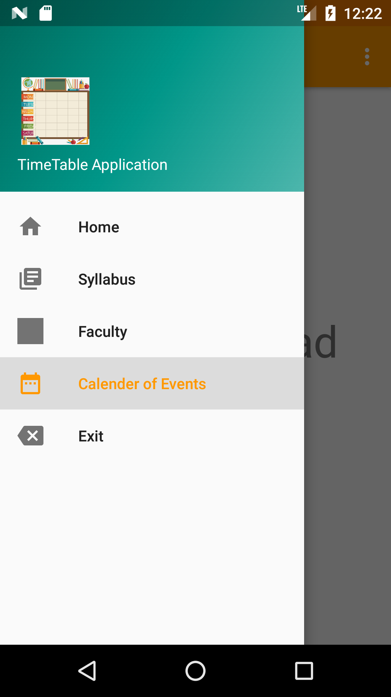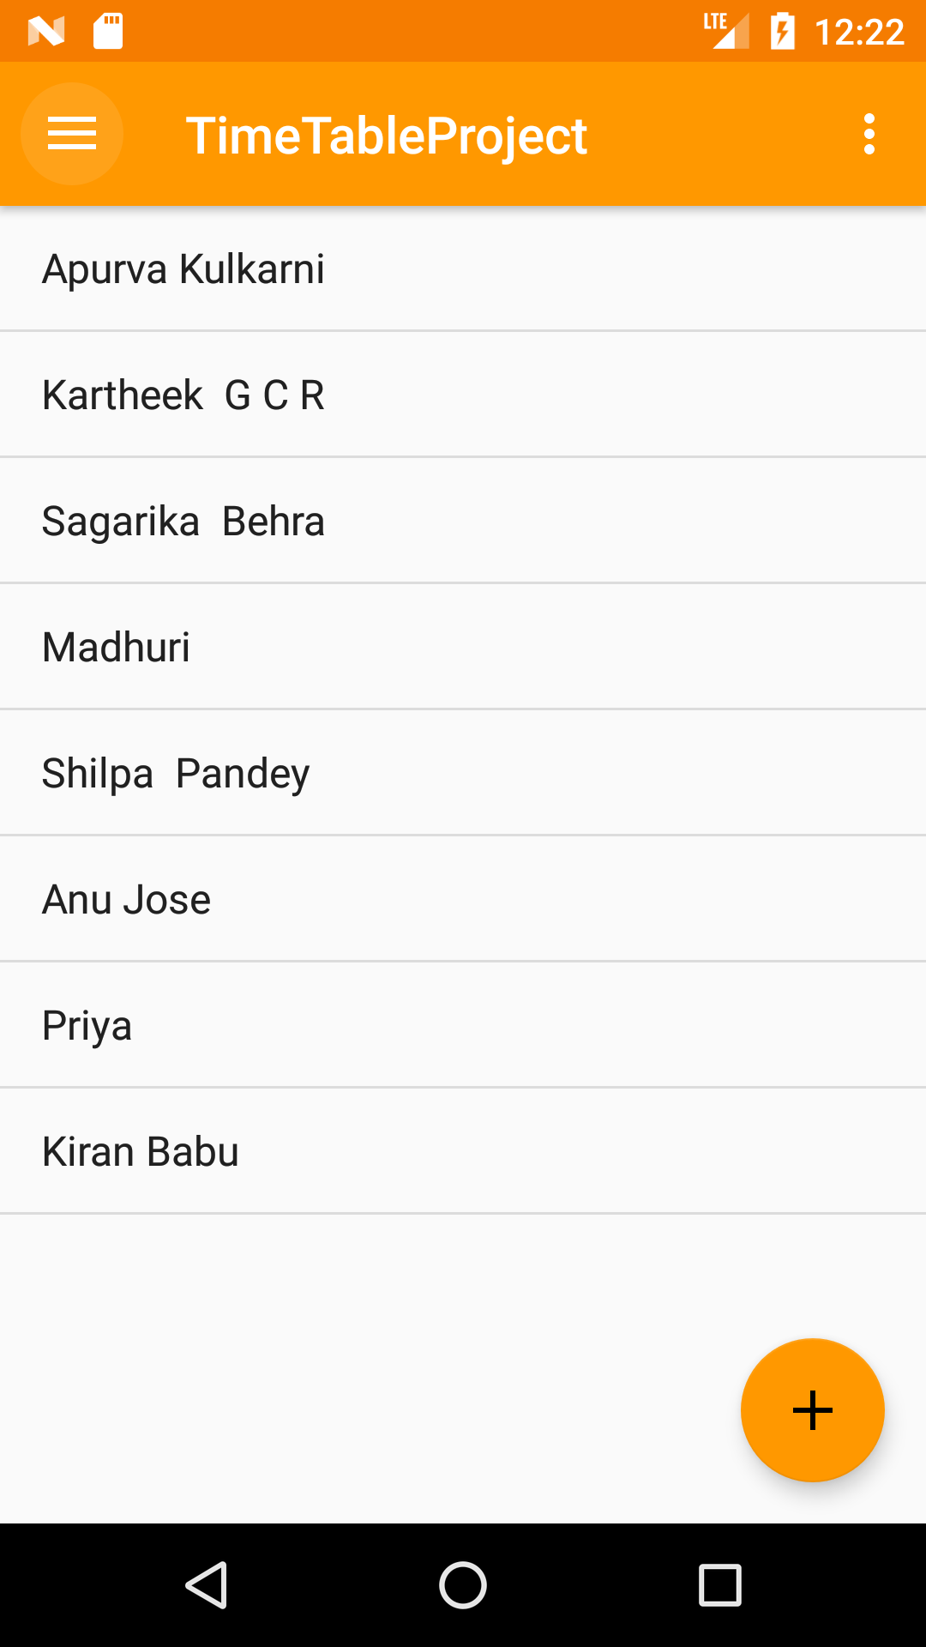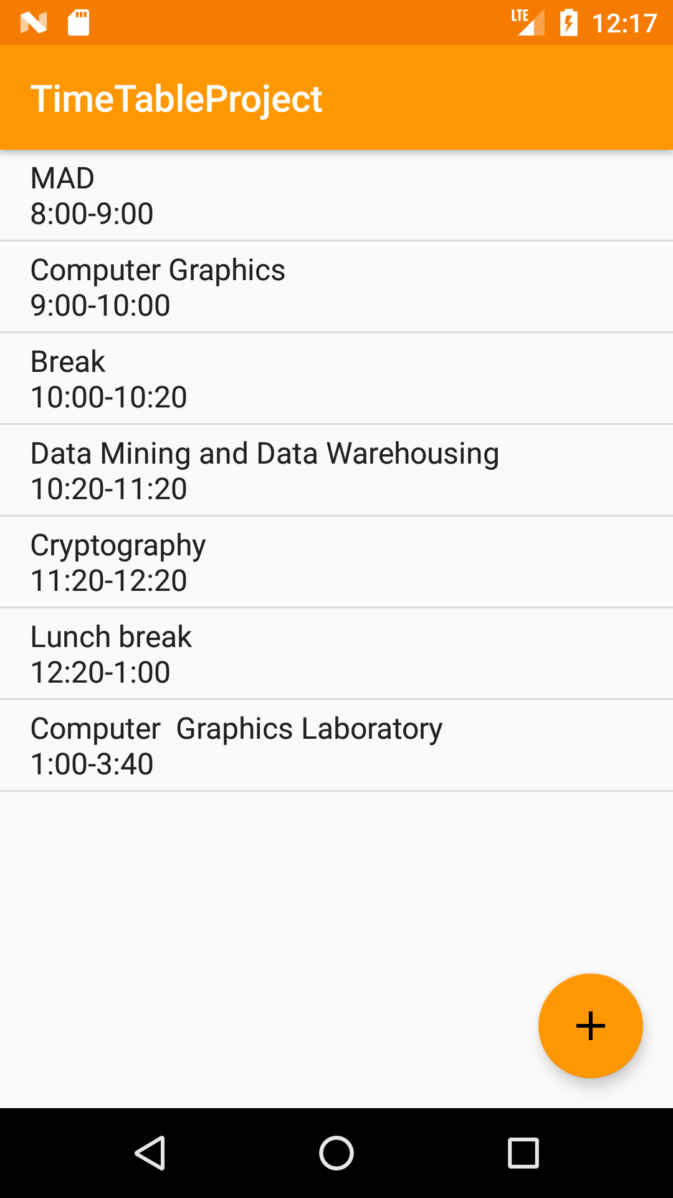

**Fig 4.1.1:** Home Screen **Fig 4.1.2:** Timetable **Fig 4.1.3:** Faculty List

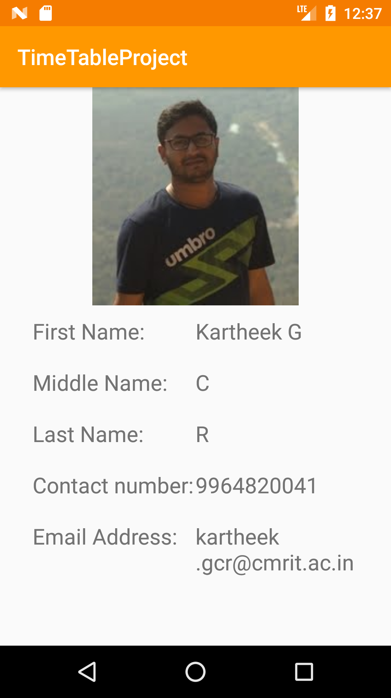

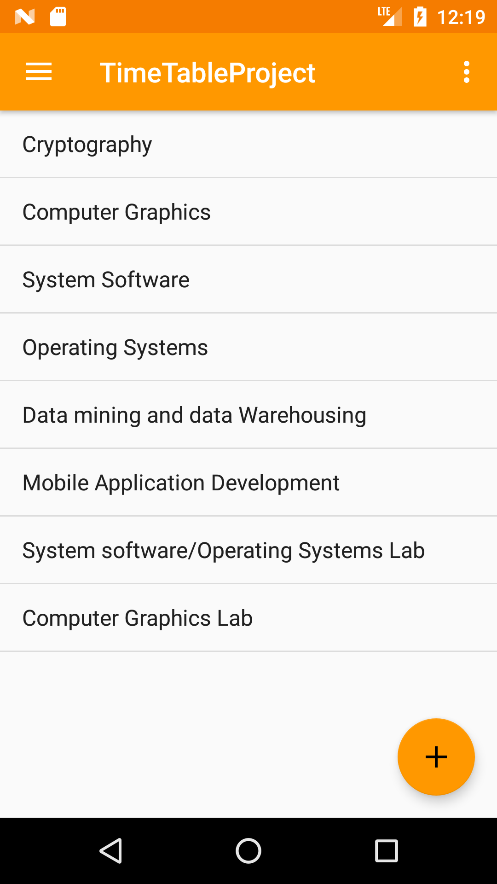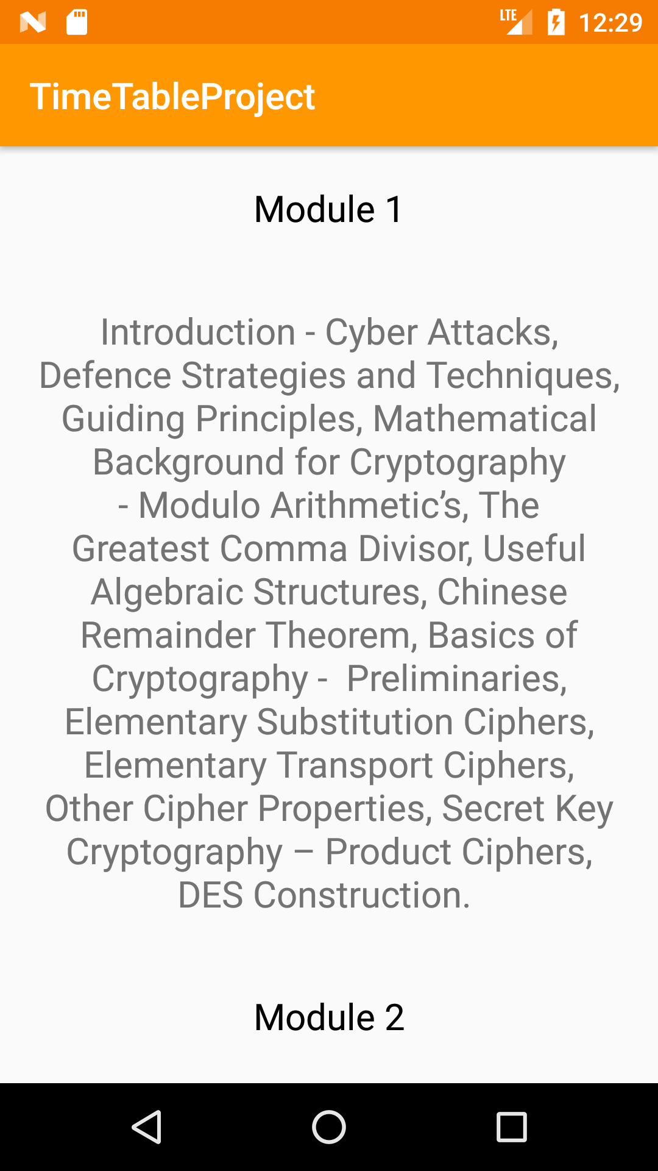

**Fig 4.1.4:** Faculty Details **Fig 4.1.5:** Subject List **Fig 4.1.6:** Syllabus

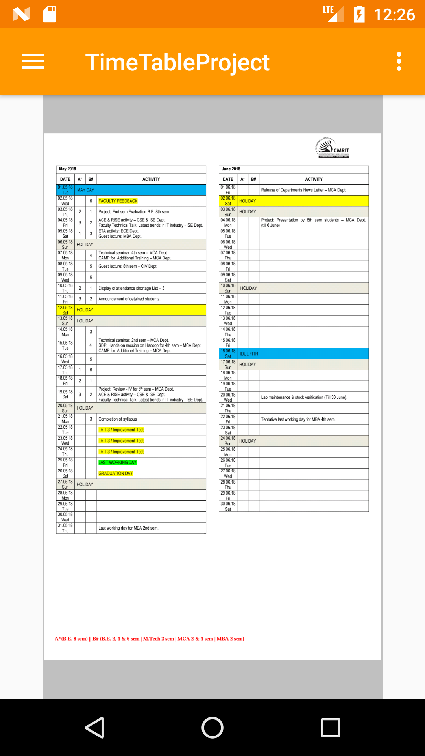

**Fig 4.1.7:** Calendar Home screen **Fig 4.1.8:** Calendar of events

**CHAPTER 5**

**CONCLUSION**

Timetable Management System contains a database, which stores the staff’s personal details, student’s daily timetable along with the subject details like the syllabus for each module and calendar of events.  
Only the administrator can view, add and delete the data in the timetable. The main objective of developing the Timetable Mobile Application is to have easy access to the timetable and view all college related details in one application that is user-friendly and easy to maintain.  
The application is also robust and produce a feasible solution for student’s problem. In our project timetable application, it will help the student access the timetable and faculty contact information.

This project gave us an opportunity to learn about working disciplines of an institute, the working standards and kind of knowledge used by an institute and real-life day to day problems that a student or a faculty comes across. Also we gained knowledge regarding how to deal with huge amount of classes and subjects, managing the students from one class to another on daily basis.